Chapter 3

3.1 Methodology

In this project, the proponents will focus on how the management, staff, and customers of WS Students & Professionals Lounge – La Paz Branch handle their daily operations to better understand their workflow. By combining different data gathering methods, the proponents will be able to collect useful and meaningful insights. These findings will help the proponents solve relevant issues such as manual reservation errors, difficulties in tracking memberships, and inaccuracies in billing and sales recording.

The proponents will conduct surveys and interviews to give them a better understanding of the manual tools the lounge currently uses to manage their data. This will also help the proponents see the bigger picture, such as how often issues like double bookings or stock discrepancies occur and how the staff feel about the current paper-based system. Based on these results, the proponents can gather data that will assist in designing and developing an Integrated Study Hub Management System that specifically meets the needs of the WS Students & Professionals Lounge.

The surveys will be used to determine the frequency of operational problems and the difficulties faced by the staff during peak hours. This will help the proponents understand the user experience and the specific pain points of the current system. The collected data will provide a basis for the proponents to assess and provide solutions to the challenges and concerns faced by the lounge administrator and employees.

Furthermore, the proponents will also perform interviews and direct observations to better know the daily routine of the lounge’s staff. Knowing the challenges through face-to-face interactions will help the proponents identify necessary improvements in the reservations, memberships, billing, and sales report process. The combination of these research methods will allow the proponents to gather both quantitative and qualitative results, combining technical information with the personal experiences of the users to help design and create the proposed management system.

3.2 Methodology Table

METHODS | PARTICIPANTS | PURPOSE
Surveys | WS Students & Professionals Lounge Owner, General Manager, Staff, and Regular Customers | To gather quantitative data regarding the frequency of manual errors and the level of satisfaction with the current system.
Interviews | WS Students & Professionals Lounge Administrator and Employees | To obtain qualitative insights into the specific operational challenges, pain points, and desired features for the new system.
Observations | WS Students & Professionals Lounge Staff and Customers | To observe the actual workflow of reservation, membership management, time room usage, and billing to identify bottlenecks in the manual process.
Data Analysis | The Proponents | To synthesize the collected data, identifying patterns in operational errors, and correlating them with system requirements.
Solution Development | The Proponents | To design and develop the Integrated Study Hub Management System based on the analyzed needs and technical specifications.

Table 1. Methodology Table

3.3 Research and Development Stage

The Research and Development (R&D) stage is essential in guiding the Integrated Study Hub Management System from conceptualization to full implementation. This stage is dedicated to ensuring that the system specifically addresses the unique challenges of WS Students & Professionals Lounge. The process begins with extensive research to understand the current manual workflow and the frustrations of the staff regarding data integrity and customer service speed.

The proponents will analyze existing management systems to identify industry best practices while focusing on the specific needs of a study lounge environment. Through data-gathering methods such as surveys, interviews, and observations, the proponents will document the risks associated with the current manual setup, including issues in user registration, reservation handling, membership management, time-based room usage tracking (duration or expiration), billing, and sales report generation. This data will serve as the foundation for defining the functional requirements of the system.

After the data-gathering phase, the proponents will transition to the Design Stage. In this phase, the proponents will create the system’s architecture, focusing on key features such as user registration, reservation bookings, membership management, time-based room usage tracking (duration or expiration), billing, and sales report generation. The goal is to develop a user-friendly interface that simplifies the staff’s workload. Throughout this process, the proponents will use the initial feedback to ensure the design remains intuitive and responsive to the users’ needs.
Following the design, the proponents will proceed to the Development phase. This is where the actual coding and building of the system take place. The proponents will focus on creating a functional prototype that integrates the front-end interface with a secure back-end database. The development will be iterative, meaning the proponents will continuously refine the features based on preliminary internal testing to ensure the system is stable and efficient.

Once the prototype is fully developed, it will enter the Testing Phase. The system will undergo rigorous testing, including functionality testing, data integrity checks, and User Acceptance Testing (UAT). The proponents will involve the WS Students & Professionals Lounge staff to test the system in a controlled environment to ensure it can handle real-world scenarios like peak-hour bookings. Any bugs or vulnerabilities identified during this phase will be rectified before the final deployment.

Lastly, the R&D process concludes with Evaluation. The proponents will review the overall performance of the system against the initial objectives. By analyzing the final test results and user feedback, the proponents will confirm if the system effectively solves the identified problems of manual errors and tracking difficulties. Once all requirements are satisfied, the Integrated Study Hub Management System will be ready for full implementation, providing a secure and organized digital environment for the lounge.

3.4 Research Design

This study uses a developmental research design because the main goal of the proponents is to design and build a functional system that will solve the operational problems of WS Students & Professionals Lounge. The proponents will focus on creating a tool that is practical and can be used in the real-world setting of the business.

A descriptive approach is also used to help the proponents understand the current situation of the lounge. This involves looking into how the staff currently work, identifying the common problems they encounter, and knowing what specific features are needed for the new system. By describing the existing manual process, the proponents can better design a solution that fits the needs of the lounge administrator, staff, and customers.

3.5 System Development Methodology

The project follows the process of the System Development Life Cycle (SDLC) methodology, following these phases:

- Planning – In this phase, the proponents will identify the problems in the manual operations of WS Students & Professionals Lounge, such as reservation errors and the difficulty of tracking memberships, billing, and daily sales report. The proponents will also define the system requirements and scope to make sure the project addresses the issues in manual recording, inaccurate data handling, and the slow process of managing customer information.

- Analysis – The proponents will gather data through surveys, interviews, and direct observations with the administrators, staff, and customers of WS Students & Professionals Lounge. This includes analyzing the risks of using paper-based logs, such as data loss, double bookings, and the time-consuming process of manually checking and updating records, including reservation details and billing transactions.

- Design – The proponents will create a simple and user-friendly interface that is easy for the lounge staff to navigate. This phase also includes designing a database that can securely store customer information, membership records, reservation details, room rates/services, billing data, and sales reports to make data retrieval much faster.

- Implementation – The proponents will begin developing the system and setting up the necessary database. Key features will be implemented, including user registration, real-time reservation management, an automated membership tracker, time-based room usage monitoring (duration or expiration), billing transactions, and sales report generation. Security features such as user login accounts and activity logs will also be included to make sure that the lounge data is protected and only authorized staff can access it.

- Testing – The proponents will check all the features of the system to make sure there are no bugs or errors. They will test if the registration, reservation, membership, billing, and sales report modules are working correctly. The staff of WS Students & Professionals Lounge will also be asked to try the system to see if it meets their expectations and if it is easy enough for them to use during their daily operations.

- Deployment – In this phase, the proponents will launch the system for actual use in the WS Students & Professionals Lounge. The proponents will also provide training for the employees to teach them how to use the system confidently and safely. The system will be monitored to ensure it runs smoothly, and the proponents will be ready to answer any questions from the staff to guarantee a good user experience.

3.6 Agile Development Methodology
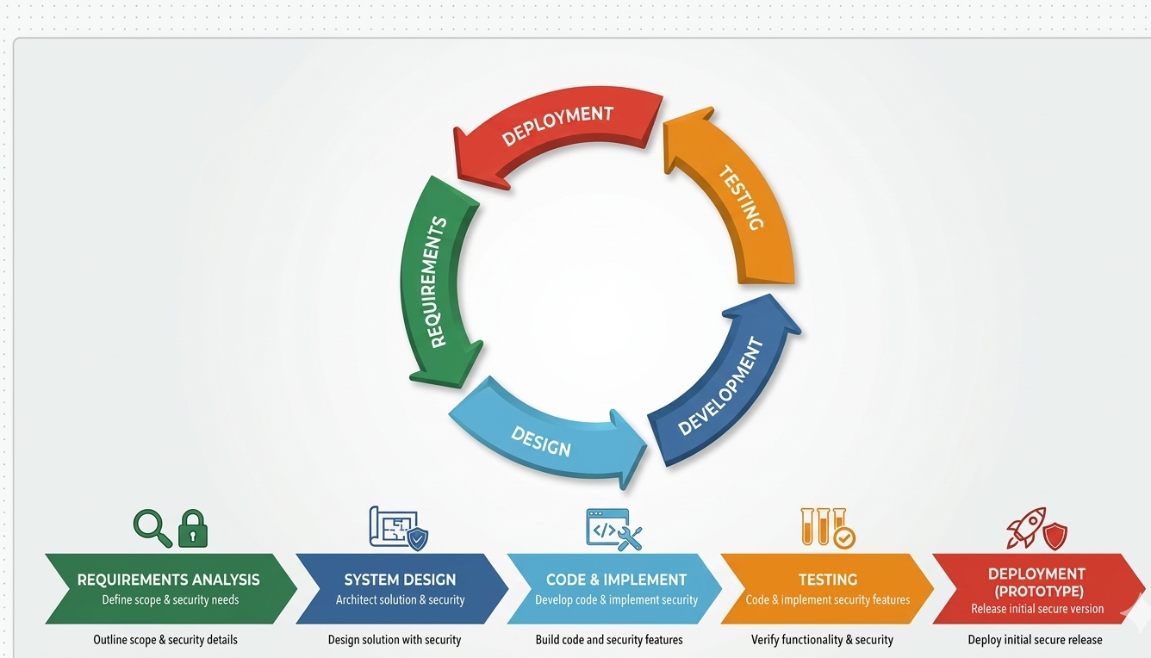

Figure 2. Agile Methodology

The Agile Methodology is chosen for the Integrated Study Hub Management System because the project aims to develop a secured, organized, and user-friendly system for the WS Students & Professionals Lounge. Agile is flexible and adaptable to changing requirements, which is important since the needs for managing user registration, reservations, membership tracking, time-based room usage, billing transactions, and sales reporting may be refined during development. This methodology allows the proponents to receive continuous feedback and opinions from the lounge management, making sure that the final system effectively addresses their manual operational issues. It also promotes strong collaboration between the proponents and the client, ensuring that their expectations are met and all technical challenges are identified and resolved early.

In the Requirements Analysis phase, the proponents will gather detailed information about the current manual processes of the lounge. This includes identifying specific problems such as double bookings, manual inventory errors, and the difficulty of tracking membership duration. The proponents will define the system requirements and scope to ensure that the proposed system directly addresses the operational challenges of the lounge staff and administrator.

During the System Design phase, the proponents will plan and design the overall architecture of the system, including its features and layout. This involves creating a user-friendly interface for the reservation, membership management, and billing modules, as well as designing a robust database to securely store user information, membership details, reservation data, time-based room usage, billing transactions, and sales reports securely. The design will focus on making the system intuitive for the staff to minimize the learning curve and ensure a smooth transition from paper-based processes to a digital system.

In the Development phase, which involves coding and implementation, the proponents will build the system based on the finalized design. The core features, such as user registration, real-time reservation management, automated membership tracking, time-based room usage monitoring (duration or expiration), billing transactions, and sales report generation, will be programmed and integrated. The proponents will ensure that the technology used is stable and capable of handling multiple transactions simultaneously without having data errors or system delays.

For the Testing phase, the proponents will conduct rigorous evaluation to ensure that the system functions properly and is free from critical errors. This includes verifying the accuracy of billing calculations, the reliability of reservation management, and the effectiveness of the preventing scheduling conflicts feature. The staff and administrator of WS Students & Professionals Lounge will also be invited to test the system prototype to determine whether it meets their requirements and to identify any necessary improvements before final implementation.

Lastly, in the Deployment phase, the proponents will present the system as a fully functional prototype for the WS Students & Professionals Lounge. This includes conducting a basic orientation or training session for the staff to ensure they know how to use the system effectively and confidently. The proponents will also monitor the initial usage of the system to guarantee a smooth user experience and gather final feedback to ensure that the system is fully ready for the lounge’s daily operations.

3.7 Data Collection Techniques

To design and develop an Integrated Study Hub Management System that truly meets the needs of the management, staff, and customers of WS Students & Professionals Lounge, the proponents will gather important data and insights using different techniques and methods. These techniques will help the proponents ensure that the system is user-friendly, efficient, and aligned with the problems and issues that need to be solved.

1. Surveys

The proponents will distribute surveys to the target users, including the lounge owner, general manager, staff, and employees. These surveys will help the proponents understand how they currently handle reservations, membership management, billing transactions, and sales reports, as well as the common problems they encounter and their expectations for a more organized digital system. The survey questions will also cover usability, system efficiency, and preferred features, which will guide the proponents in further development of the system.

2. Interviews

The proponents will conduct one-on-one interviews with the lounge administrator and selected staff members who are involved in managing daily operations, including reservations, billing, and record-keeping. This will allow the proponents to gain a deeper understanding of the challenges faced by the lounge in more detail—information that a simple survey might not provide. The proponents will ask the interviewees to share their personal experiences, concerns, and ideas on how to improve the efficiency and reliability of the reservation, billing, and management processes.

3. Focus Groups

The proponents will also organize a small group discussion with the lounge staff and manager to further discuss the proposed management system. This discussion will allow each participant to share their opinions, suggestions, and concerns regarding the planned features. By doing this, the proponents can identify which concerns are the most important and prioritize which features should be developed first to better meet the user’s needs.

4. Observations

To better understand the daily workflow, the proponents will conduct direct observations of the existing manual processes being used in the lounge. This includes monitoring how the users' or members' information is recorded, how reservations are made, how the availability of study pods is checked, how the time duration/expiration of every customer is used, how the billing is transacted, and how the sales report is tracked. This will help the proponents spot the exact parts of the process where delays and errors usually happen.

5. Document Analysis

The proponents will also review existing records, logs, and articles related to study hub management and POS (Point of Sale) systems. This includes examining past reservation logs, billing records, sales report lists, and relevant studies on automated management systems. Through this analysis, the proponents will gain a clearer understanding of current practices and identify best practices that can be applied in developing a system tailored specifically to the needs of the WS Students & Professionals Lounge.

3.8 System Architecture and Design

Overview

The Integrated Study Hub Management System is designed to make the daily operations of WS Students & Professionals Lounge more organized, efficient, and digital-friendly. The system is built to solve the problems of manual recording, double bookings, and the hard way of tracking memberships, billing transactions, and sales reports. By moving from a paper-based system to a digital one, the lounge can ensure that all data is kept in a safe and organized place, making it easier for the staff to manage the hub and for the customers to enjoy the services.

The system supports different types of users, specifically the Admin, Staff, and Customers, each having their own roles and duties. The Admin has full control, such as managing user accounts and reservations, viewing detailed sales reports, and tracking the overall operations of the lounge. The Staff can handle the real-time reservations, process users or members information details, check room availability status, and billing transactions. Meanwhile, the Customers can easily view available study pods and manage their reservations or bookings. This organized flow ensures that the lounge’s operation is smooth and that errors are avoided.

3.9 System Architecture

The Integrated Study Hub Management System will be developed using a Three-Tier Architecture to ensure a structured, scalable, and organized flow of data. This architecture consists of the following three layers:

- Presentation Layer – This layer provides the user interface (UI) where administrators, staff, and customers can interact with the system. It features a responsive dashboard for user registration, monitoring room occupancy, making reservations, and processing membership. For the administrator and staff, it includes management panels for handling users, reservations, memberships, transaction records, and real-time sales reporting. This layer also uses Role-Based Access Control (RBAC) to ensure that the interface and menus are customized based on the user’s role—restricting sensitive management functions to authorized personnel while providing a simple, user-friendly interface for customers to register, make reservations, and view relevant account or billing information.

- Application or Logic Layer – This serves as the "brain" of the system that handles all user requests and processes the core business logic. It includes the User Management module for handling user registration and authentication, the Reservation Module that checks for room availability and prevents double bookings, the Membership Module that manages membership status, calculates usage duration, and subscription validity, the Billing Module that processes and calculates payments accurately, and the Sales Report Module that generates transaction summaries. This layer ensures that all operations are validated and correctly processed before sending or retrieving data from the database and returning results to the presentation layer.

- Database Layer – This layer is responsible for the secure and organized storage of all essential information using MySQL. It stores user profiles, membership records, transaction logs, room schedules, billing transactions, and sales reports. The database layer ensures data integrity, consistency, and security, making sure that every transaction and system activity is recorded accurately. It also allows fast and reliable data retrieval for real-time processing, reporting, and auditing purposes.

3.9.1 System Architecture Diagram

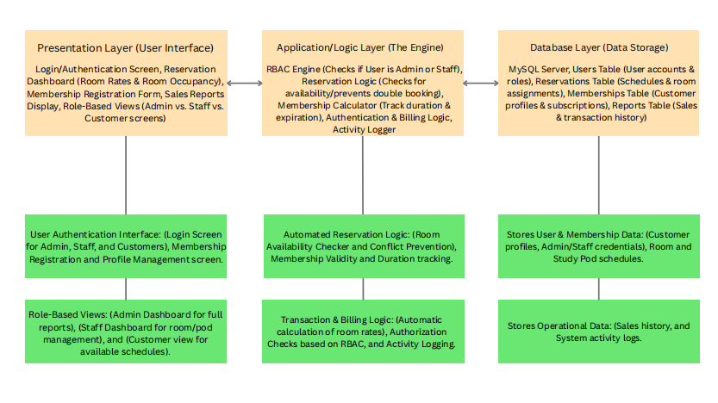

System Architecture Diagram

Figure 3. System Architecture Diagram of Integrated Study Hub Management System

3.10 System Components and Modules

The Integrated Study Hub Management System is made up of different modules that work together to create a simple and organized management tool. It uses automated tracking and role-based access to make sure that the operations are smooth and secured from errors or unauthorized access.

User Management Module
This manages the login and profiles of the admin, staff, and customers. Its key features include secure login for different user levels, profile management for members, and password management to keep accounts safe. It also handles session management to make sure that only authorized staff can access the management dashboard.

Reservation Booking Module
This is the core module for managing study pods and rooms. Its key features include a real-time availability checker to avoid double bookings, a walk-in/reservation form for customers and staff, and a schedule monitor that shows which rooms are occupied or vacant. It also tracks the time duration of stay to help the staff manage the turnaround of customers.

Membership Subscription Module
This module handles the records of regular members of the lounge. Its key features include a registration system for new members, tracking of membership expiration dates, and a history of their visits. It helps the management identify loyal customers and manage special discounts or membership perks.

Sales Reports Module
This provides the tools to manage the sales, transaction history, and other supplies in the lounge. Its key features include an automated sales and tracker that records every transaction. This ensures that the inventory is always accurate and easy to audit.

Admin Dashboard and Reporting Module
This provides the administrator with a centralized tool to see the overall status of the business. Its key features include viewing sales reports (daily, weekly, or monthly), monitoring user activities, and managing the list of room rates. It also provides analytic reports on peak hours to help the manager decide on staffing needs.

Notification and Alert Module
This module helps in communicating important updates to the staff and customers. Its key features include alerts for successful bookings, notifications when a customer’s time is almost up, and system alerts if there are issues with the data records.

Security and Access Control Module
This part includes all the key security features of the Integrated Study Hub Management System:

- Use password encryption to protect the login details of the admin, staff, and customers.
- Implements Role-Based Access Control (RBAC) so that staff can only access the user’s or members’ details, reservation bookings, and billing while the admin can access the sensitive sales reports.
- Ensures that all reservation and membership data are backed up and safe from being lost or deleted.
- Protects the customer information from unauthorized access or data breaches.

3.11 System Architecture and Design

3.11.1 Context Diagram

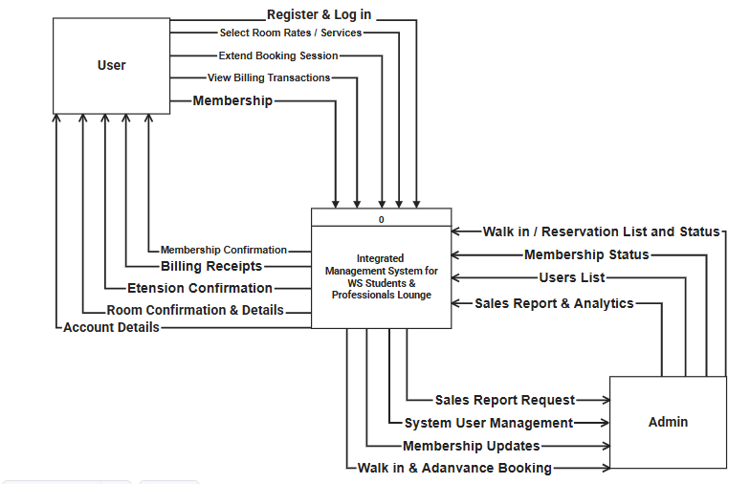

Figure 4. Context Diagram of an Integrated Study Hub Management System for WS Students & Professionals Lounge

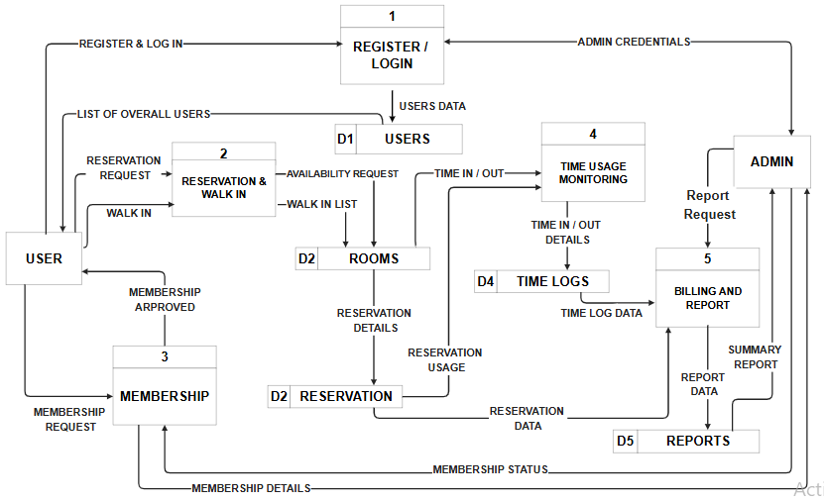

Figure 5. Data Flow Diagram of an Integrated Study Hub Management System for WS Students & Professionals Lounge

Significance of Context and Data Flow Diagram

The hierarchical structure of the context diagram and the Data Flow Diagrams (DFDs) provides a detailed blueprint of the Integrated Study Hub Management System for WS Students & Professionals Lounge. It outlines the flow of information from the conceptual overview down to the specific operational processes, ensuring that every transaction—from room bookings to sales report updates—is properly tracked and organized.
As shown in Figure 4. Context Diagram, the system’s scope is established by outlining the primary interactions between the external entities and the core system. The User initiates the flow by submitting registration requests, login credentials, room booking reservations, and requests to extend booking sessions. In return, the system provides confirmations, room details, and billing receipts. Simultaneously, the Admin interacts with the system by managing room rates, monitoring customer walk-ins, and performing system user management. The Admin also receives critical outputs such as sales reports and analytic through this centralized flow.
Moving to the Level 1 DFD, these high-level interactions are decomposed into five discrete sub-functions: Register/Login, Reservation & Walk-in, Membership, Time Usage Monitoring, and Billing and Report. For example, when a user makes a reservation, the system checks for availability against the Rooms (D2) data store. The Time Usage Monitoring process tracks "Time In/Out" details, which are then recorded in the Time Logs (D4) to ensure accurate duration tracking.
The Level 2 and Level 3 DFDs provide the most detailed view of the system's internal actions, such as the automatic calculation of total billing based on the data retrieved from time logs and reservation usage. This detailed modeling approach helps in design validation and ensures that all technical and operational requirements of the WS Students & Professionals Lounge are met, providing a smooth and error-free experience for everyone.

3.11 Use-Case Diagram

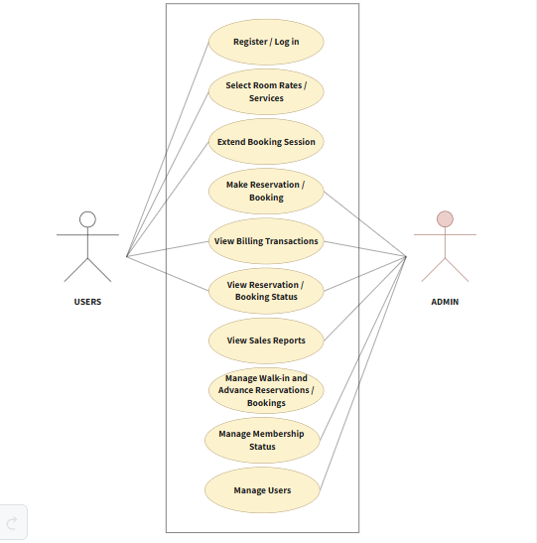

Figure 6. Use-Case Diagram of an Integrated Study Hub Management System for
WS Students &u Professionals Lounge

Significance of Use-Case Diagram

The Use-Case Diagram for the Integrated Study Hub Management System is essential as it illustrates the dynamic behavior of the platform by defining the interactions between the users and the various functions of the system. It establishes a structured and secure approach to lounge management by mapping out the specific tasks that the two primary actors—the User (Students/Professionals) and the Admin (Staff/Management)—can perform within the system's boundary. It presents the main functions available within the system and shows how each actor interacts with these features to support the daily operations of WS Students & Professionals Lounge. By defining these interactions, the diagram helps ensure that all system requirements are clearly identified and properly organized according to user roles and responsibilities.
From the users’ perspective, the system provides a simple and user-friendly process for accessing study hub services. Users can Register/Log In, Select Room Rates/Services, Make Reservations/Bookings, Extend Booking Sessions, View Reservation/Booking Status, and View Billing Transactions. These functions allow users to conveniently manage their reservations and monitor their transactions within the system. The diagram emphasizes a streamlined booking experience that reduces manual processing and improves accessibility for customers.
For the administrators and staff, the system provides management and monitoring capabilities necessary for daily operations. Admins can manage reservations, oversee membership status, handle walk-in and advance bookings, manage user accounts, and monitor billing and sales reports. Through the View Sales Reports feature, administrators can review summarized transaction records to support operational monitoring and decision-making.
Overall, the Use-Case Diagram demonstrates how the proposed system supports efficient reservation management, organized user handling, accurate billing, and sales monitoring. It also highlights the role-based structure of the system, ensuring that each actor is provided with appropriate access and functions to maintain security, efficiency, and effective study hub management.

3.12 Entity Relationship Diagram (ERD)
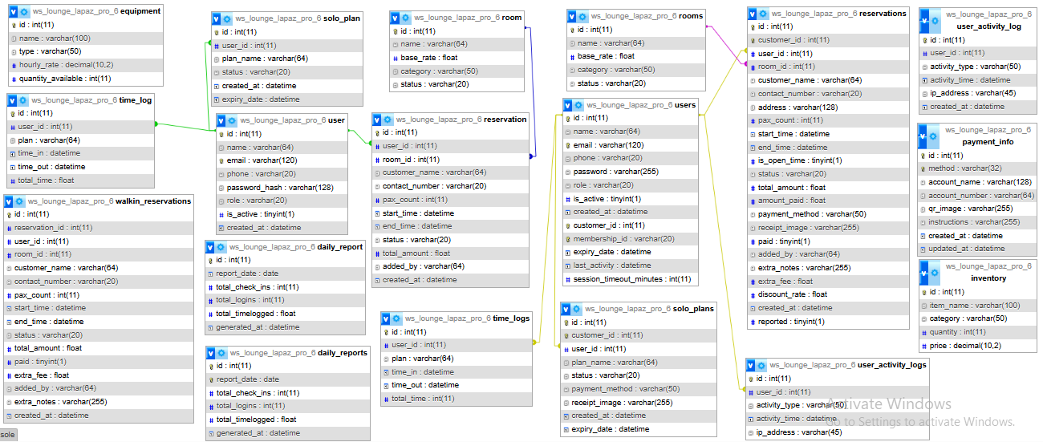

Figure 7. Entity Relationship Diagram of Integrated Study Hub Management System

Significance of Entity Relationship Diagram
The Entity-Relationship Diagram (ERD) serves as the foundational architectural blueprint for the data management layer of the Integrated Study Hub Management System. By providing a visual and structural representation of the relational schema, the ERD allows the researchers to conceptualize how complex business operations—such as multi-tier room reservations, inventory distribution, dynamic time-logging, and digital payments—are translated into organized data entities (Pressman & Maxim, 2020).
The primary significance of this diagram lies in its capacity to enforce structural data integrity and prevent relational anomalies. Through the precise application of cardinal and key constraints, the diagram maps out the direct dependencies between core user activities and security logs, ensuring that no orphan records occur during high-volume transactions. As a Database Design Map, each entity defined in the ERD directly correlates to physical database tables where attributes, primary keys, and foreign keys are explicitly declared to maintain high data consistency (Silberschatz et al., 2019). Furthermore, the ERD acts as a critical validation tool among the proponents and stakeholders, ensuring that the programmatic flow of the application aligns perfectly with the actual operational constraints and administrative workflows of the WS Students & Professionals Lounge.

3.13 Database Design

The database of the Integrated Study Hub Management System is engineered to securely store, organize, and retrieve critical operational metrics, financial transactions, and user histories. The system utilizes a relational database model implemented via MySQL, where data tables are heavily interconnected through Primary Keys (PK) and Foreign Keys (FK) to secure data synchronization (Silberschatz et al., 2019).
The following are the finalized main tables, structural schema, and operational roles derived directly from the system’s physical database design:

1. users (ws_lounge_lapaz_pro_6_users)
- Operational Role: The core entity that holds demographic, access level, and active status records for all individuals interacting with the hub, including Administrators, Front-desk Staff, and General Customers.
- Attributes and Schema Specifications:
id: int(11) (PK) — Unique auto-incremented identifier for each user.
name: varchar(64) — Full name of the user.
email: varchar(120) — Registered email address for notifications and logins.
phone: varchar(20) — Active contact number of the user.
password: varchar(255) — Secure, hashed authentication password.
role: varchar(20) — System privilege classification (e.g., Admin, Staff, Customer).
is_active: tinyint(1) — Binary flag for account status validation.
created_at: datetime — Timestamp indicating account registration date.
customer_id: int(11) — External identifier for localized indexing.
membership_id: varchar(20) — Tracks active subscription numbers.
expiry_date: datetime — Deadline for account or membership validity.
last_activity: datetime — Real-time stamp for monitoring active online sessions.
session_timeout_minutes: int(11) — Security configuration variable for session lifespans.

2. reservations (ws_lounge_lapaz_pro_6_reservations)
- Operational Role: Captures the comprehensive life cycle of a workspace booking, managing scheduling details, spatial allocation, and advanced billing computations
- Attributes and Schema Specifications:
id: int(11) (PK) — Unique identifier for each booking instance.
customer_id: int(11) — Primary customer linking constraint.
user_id: int(11) (FK) — Relational link to the user table.
room_id: int(11) (FK) — Relational link to the specific room booked.
customer_name: varchar(64) — Explicit name label for rapid display queries.
contact_number: varchar(20) — Temporary or reference phone detail.
address: varchar(128) — Physical address background of the client.
pax_count: int(11) — Total headcount utilizing the reserved space.
start_time: datetime — Slotted timestamp for the commencement of the booking.
end_time: datetime — Slotted timestamp for the expiration of the booking.
is_open_time: tinyint(1) — Variable determining flexible or fixed-hour extensions.
status: varchar(20) — Operational state of the booking (e.g., Pending, Confirmed, Cancelled).
total_amount: float — Computed initial charge for space usage.
amount_paid: float — Actual cash/digital value received from the client.
payment_method: varchar(50) — Transaction mode identifier.
receipt_image: varchar(255) — File path or URL registry for digital payment proof uploads.
paid: tinyint(1) — Boolean flag confirming complete payment settlement.
added_by: varchar(64) — Audit trail tracking who encoded the transaction.
extra_notes: varchar(255) — Free-text field for special customer demands.
extra_fee: float — Overtime charges or auxiliary fee additions.
discount_rate: float — Percentages deducted based on dynamic marketing promos or loyalty tiers.
created_at: datetime — System timestamp for record generation.
reported: tinyint(1) — Admin classification flag indicating audit compilation.

3. rooms (ws_lounge_lapaz_pro_6_rooms)
- Operational Role: Acts as the primary inventory registry for physical spaces, including individual study pods, general lounges, and corporate meeting rooms.
- Attributes and Schema Specifications:
id: int(11) (PK) — Unique index for each room asset.
name: varchar(64) — Label designating the space name or room number.
base_rate: float — Standard hourly pricing blueprint for the room.
category: varchar(50) — Structural classification (e.g., Private, Shared, Group).
status: varchar(20) — Live availability status indicator (e.g., Available, Occupied, Maintenance).

4. time_logs (ws_lounge_lapaz_pro_6_time_logs)
- Operational Role: Functions as an immutable data ledger that tracks exact physical arrivals and exits of users, serving as the raw data feed for automated billing engines.
- Attributes and Schema Specifications:
id: int(11) (PK) — Sequential tracking code for every log instance.
user_id: int(11) (FK) — Links the timestamp directly to a specific user.
plan: varchar(64) — Tracks what specific pricing archetype is active during the duration.
time_in: datetime — Precise clock-in timestamp.
time_out: datetime — Precise clock-out timestamp.
total_time: int(11) — Net computational minutes or hours used for administrative calculation.

5. solo_plans (ws_lounge_lapaz_pro_6_solo_plans)
- Operational Role: Manages individualized, non-group workspace subscription plans, tracking user-specific membership duration and active cycles.
- Attributes and Schema Specifications:
id: int(11) (PK) — Unique primary index for individual plans.
customer_id: int(11) — System indexing code for identification.
user_id: int(11) (FK) — Ties the billing package to an authenticated client account.
plan_name: varchar(64) — Name classification of the subscription package.
status: varchar(20) — Current state of the plan validity (e.g., Active, Expired).
payment_method: varchar(50) — Selected channel for payment collection.
receipt_image: varchar(255) — Digital log file for proof of payment verification.
created_at: datetime — Commencement date of the individual plan subscription.
expiry_date: datetime — Mandatory programmatic cutoff date for the subscription.

6. daily_reports (ws_lounge_lapaz_pro_6_daily_reports)
- Operational Role: A data warehouse entity that consolidates transaction logs and user entries into high-level business intelligence snapshots for management review.
- Attributes and Schema Specifications:
id: int(11) (PK) — Unique report sequence index.
report_date: date — Specific operational calendar date being evaluated.
total_check_ins: int(11) — Aggregated count of successful physical entries for the day.
total_logins: int(11) — Total authentication attempts tracked within the web portal interface.
total_timelogged: float — Cumulative number of workspace hours consumed by clients within the specific date.
generated_at: datetime — Microsecond timestamp indicating exact system report generation time.

7. equipment (ws_lounge_lapaz_pro_6_equipment)
- Operational Role: Monitors auxiliary tangible assets that can be rented or utilized within the lounge, such as projectors, extension wires, and adapters.
- Attributes and Schema Specifications:
id: int(11) (PK) — Unique structural ID for every equipment entry.
name: varchar(100) — Label text for the specific machine or item.
type: varchar(50) — Equipment classification tag (e.g., Electronics, Peripheral, Furniture).
hourly_rate: decimal(10,2) — Fixed surcharge cost added when the specific asset is rented out.
quantity_available: int(11) — Operational inventory stock monitoring variable.

8. user_activity_logs (ws_lounge_lapaz_pro_6_user_activity_logs)
- Operational Role: Serves as a vital security audit trail that archives user activities to detect system exploitation and ensure internal operational transparency.
- Attributes and Schema Specifications:
id: int(11) (PK) — Automated security record ID.
user_id: int(11) (FK) — Connects the malicious or standard system action to an explicit account.
activity_type: varchar(50) — System action definition tag (e.g., Login Attempt, Reservation Creation, Report Generation).
activity_time: datetime — Definitive date and hour log of the action.
ip_address: varchar(45) — Captures the unique network point location of the device used for the operation.

9. payment_info (ws_lounge_lapaz_pro_6_payment_info)
- Operational Role: Manages digital remittance architectures and payment routing channels for customer awareness during checkout phases.
- Attributes and Schema Specifications:
id: int(11) (PK) — Unique payment channel identifier.
method: varchar(32) — Financial gateway type (e.g., GCash, PayMaya, Bank Transfer).
account_name: varchar(128) — Business register holder name for receipt verification.
account_number: varchar(64) — Explicit account numeric string where cash flows are targeted.
qr_image: varchar(255) — String directory for the dynamic graphic display of scanned payment assets.
instructions: varchar(255) — Explicit step-by-step text guiding the user through the transaction process.
created_at: datetime — Blueprint formulation timestamp.
updated_at: datetime — Track log for adjustments in administrative banking structures.

10. inventory (ws_lounge_lapaz_pro_6_inventory)
- Operational Role: Keeps track of consumable internal resources or items sold within the hub (e.g., snacks, beverages, printing paper).
- Attributes and Schema Specifications:
id: int(11) (PK) — Unique primary catalog index.
item_name: varchar(100) — Description or name of the physical stock.
category: varchar(50) — Classification category (e.g., Food, Beverage, Office Supplies).
quantity: int(11) — Numerical data tracking remaining units on hand.
price: decimal(10,2) — Operational retail unit value for point-of-sale calculations.

3.14 User Interface Design

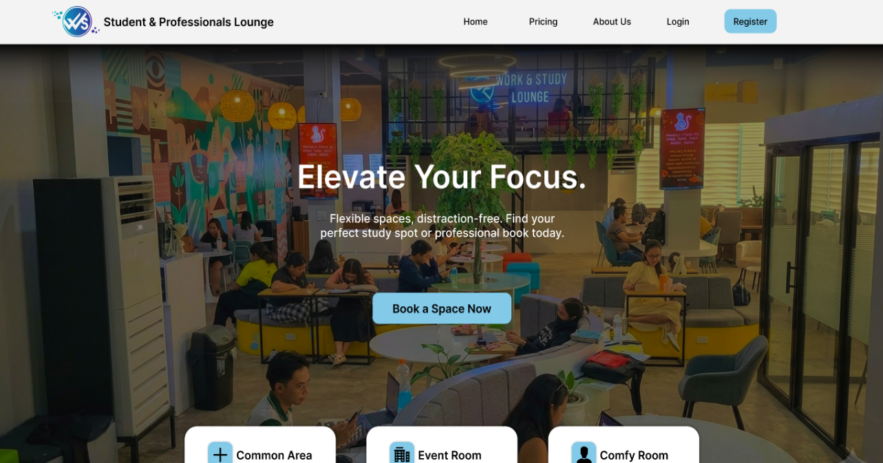
Landing Page

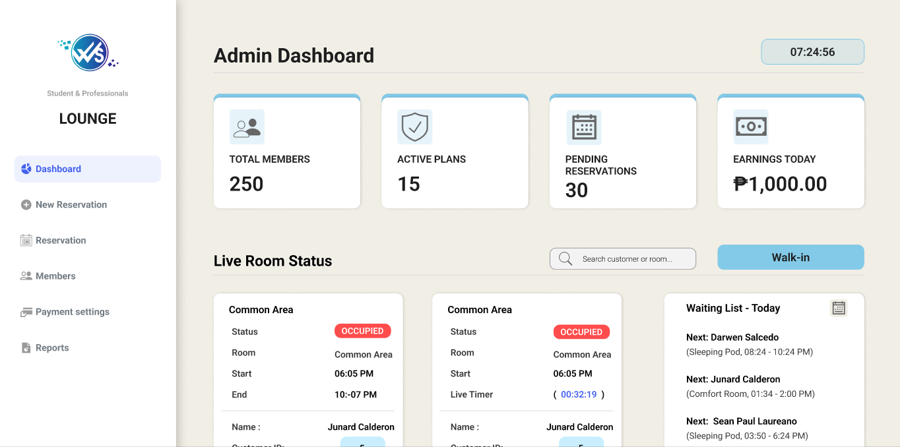
Admin Dashboard

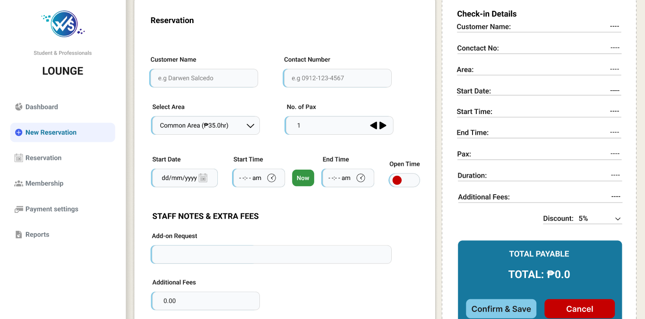
Reservation Bookings

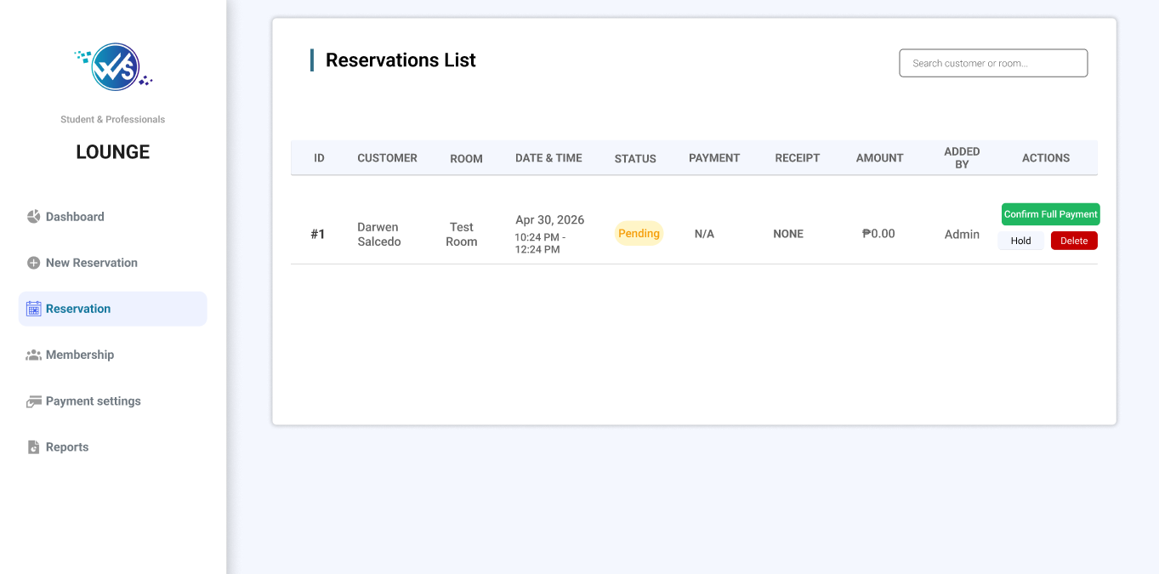

Reservations List

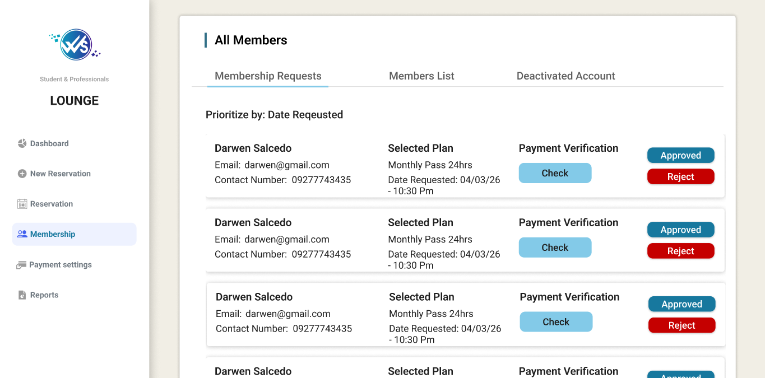
Membership Page

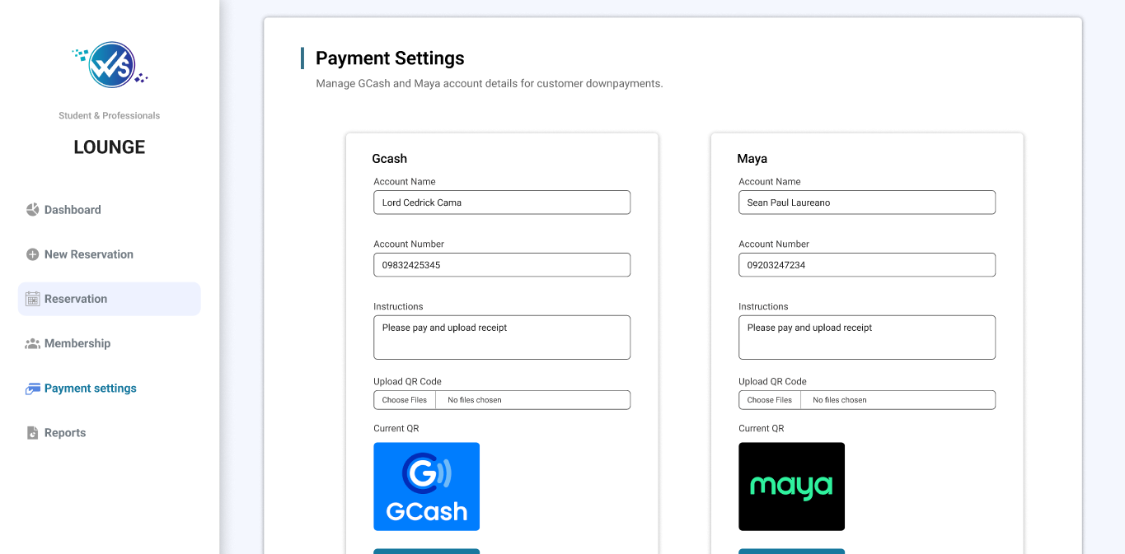
Billing Page

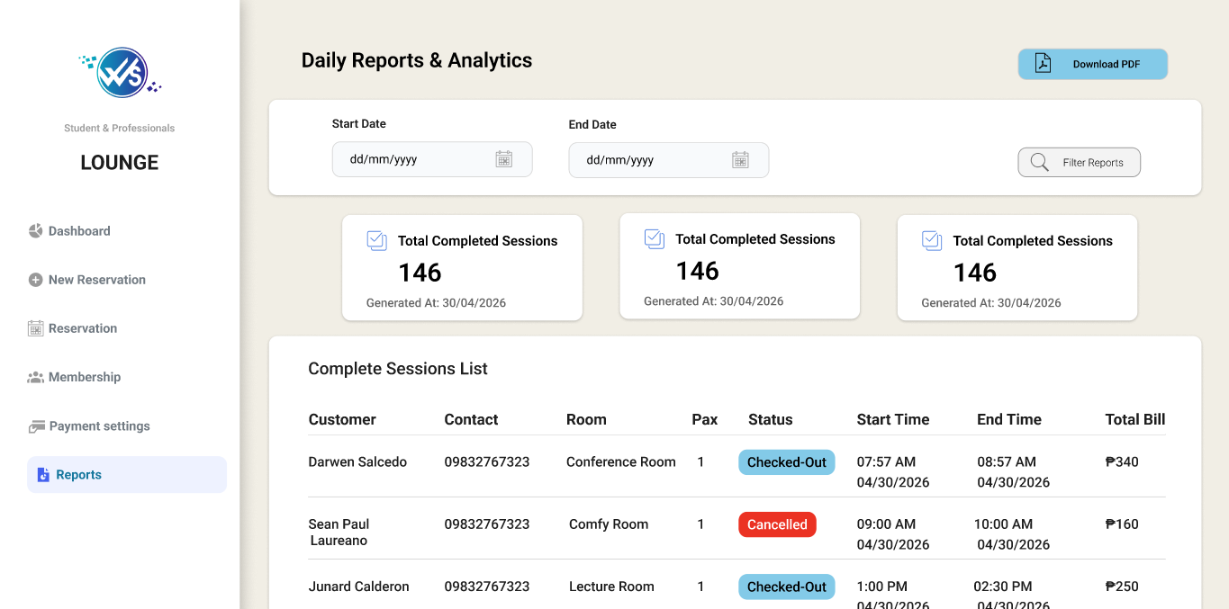
Report History

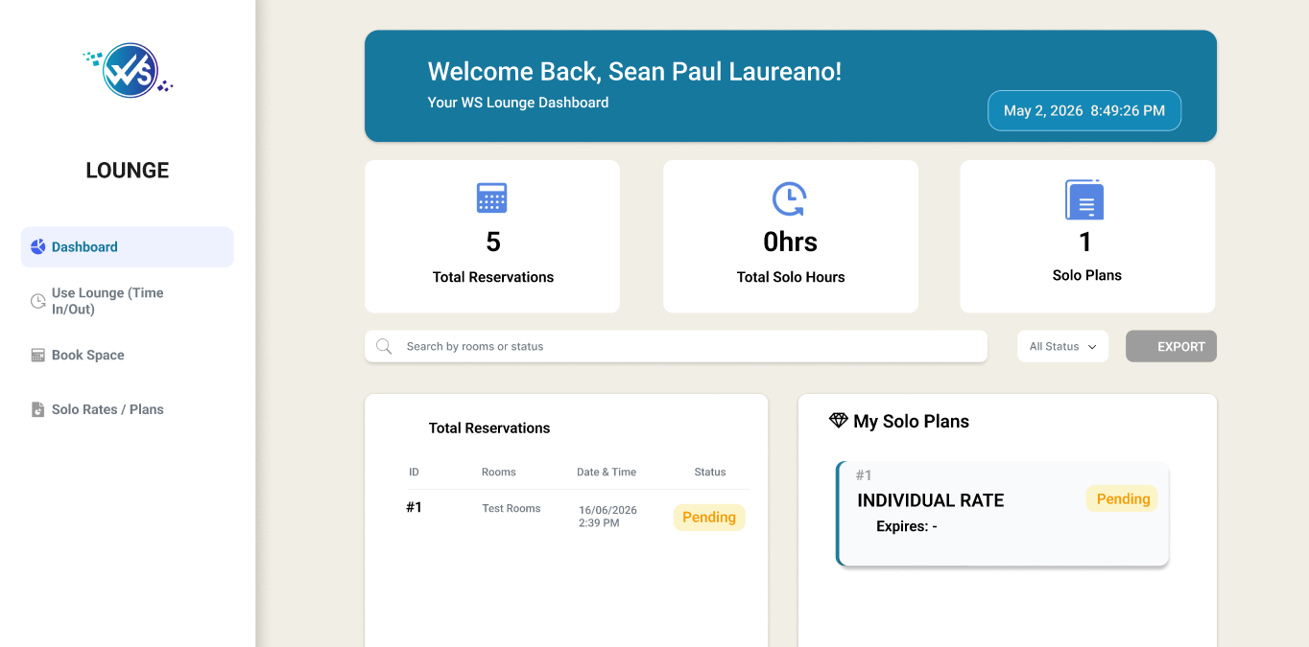
User Dashboard

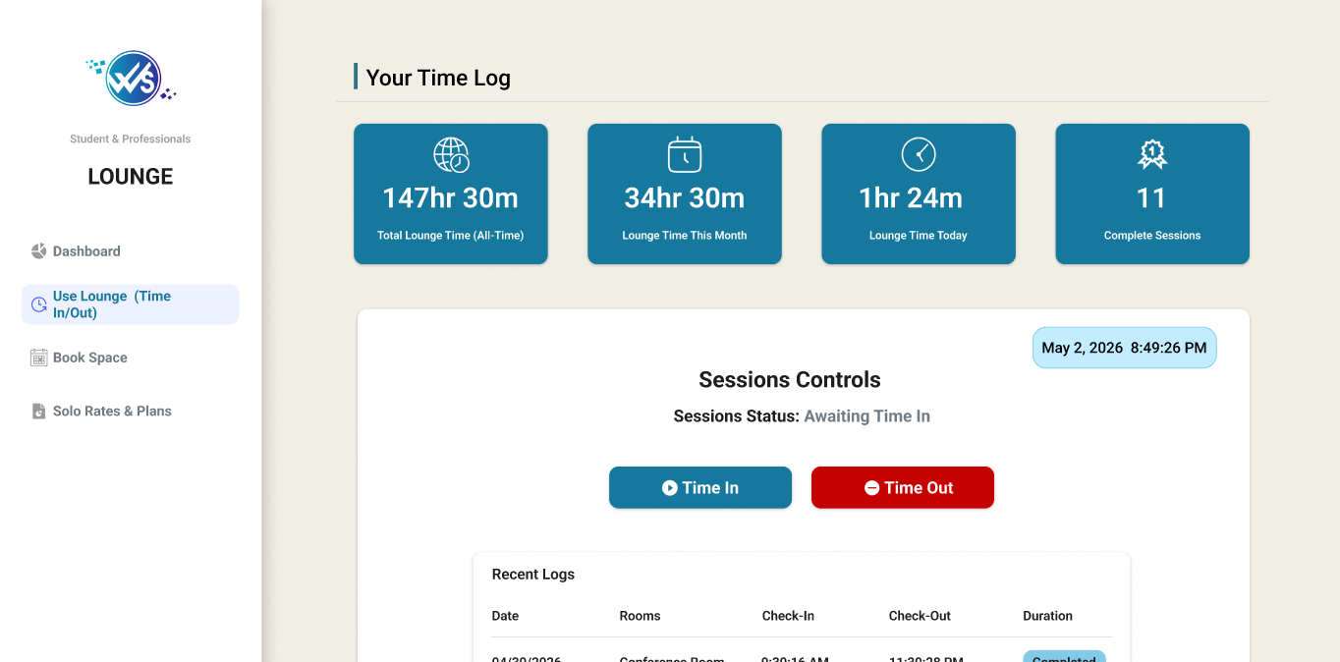
Time Logs

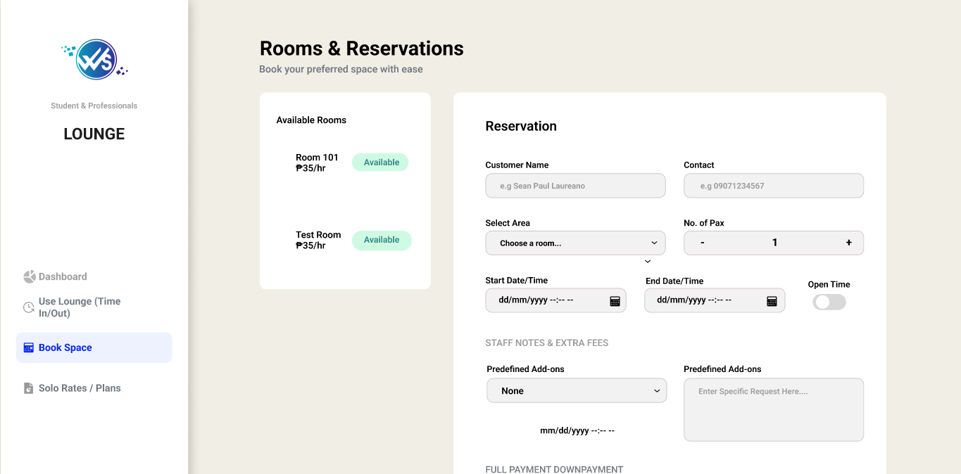
Reservation Page

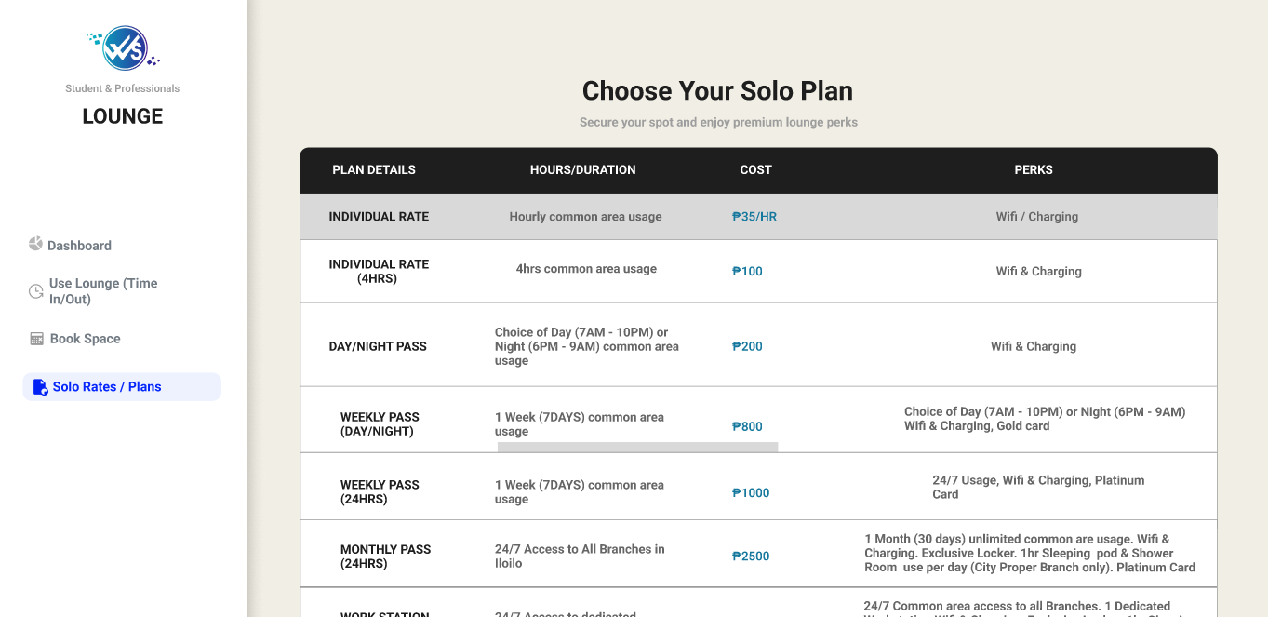
Membership Plans

The Integrated Study Hub Management System is composed of several interconnected modules designed to streamline the operations of the WS Students & Professionals Lounge. These components work in harmony to ensure data integrity, security, and a seamless user experience. The system includes the following interfaces:

- Landing Page: The digital gateway to the Integrated Study Hub Management System, designed to guide users toward their specific needs—whether they are customers looking for a space or staff members managing operations. It prioritizes clarity and immediate access to core functions.

- Admin Dashboard: The central command center for the Integrated Study Hub Management System, providing the branch general manager or owner with total visibility over the lounge's operations. It shifts from the transitional focus of the user to a high-level oversight of financial and operational health.

- Reservation Bookings: The system's primary scheduler, designed to manage the life cycle of a study session from the initial request to the physical check-in. It ensures that the WS Students & Professionals Lounge operates at peak efficiency by organizing space allocation and preventing scheduling conflicts.

- Reservations List: The core operational tool used by both Staff and Admin to monitor, verify, and manage all scheduled bookings within the hub. It acts as the "master schedule" that ensures the physical lounge areas are organized and utilized efficiently.

- Membership Page: The central hub for users to manage their long-term relationship with the lounge. It transitions the user from a one-time visitor to a recurring member, offering structured access to the lounge’s premium study environments and professional services

- Billing Page: The financial transaction hub of the system, responsible for processing payments, calculating dynamic rates, and issuing digital invoices. It integrates data from the Time Logs and Reservation Bookings to compute precise costs based on room categories, actual hours spent, and applied membership discounts. By maintaining an accurate, real-time ledger of accounts paid, pending fees, and uploaded proof of digital receipts, this module replaces manual computational errors with transparency, ensuring fiscal accountability for both the management and the clients

- Report History: The system’s permanent archive, allowing the Admin to look back at past performance to identify long-term trends and seasonal patterns. While Daily Reports focus on the immediate "now," the Report History provides the "big picture" necessary for longitudinal business analysis.

- User Dashboard: This serves as the primary interface for Students and Professionals, providing a real-time overview of their interactions with the Integrated Study Hub Management System. It is designed to streamline the user experience by consolidating personal activity, financial data, and resource access into a single view.

- Time Logs: The primary mechanism for tracking the physical presence and duration of stay for every student and professional in the lounge. It serves as the bridge between a reservation and the final billing process.

- Reservation Page: The interactive interface where students and professionals secure their workspace. It is designed to be intuitive, ensuring that the process of booking a study area is fast, transparent, and error-free.

- Membership Plans: Represent a tiered subscription model designed to provide consistent value for frequent visitors of the WS Students & Professionals Lounge. By categorizing users into specific plans, the system can automate pricing and access privileges according to the selected tier.

- Role-Based Access Control - The primary security protocol that regulates system access, data modification, and operational privileges across the entire platform. By enforcing strict permission boundaries, the system ensures that sensitive business metrics, financial histories, and administrative settings are restricted solely to authorized management roles, while staff and customers are presented only with the specific interfaces necessary for their respective tasks.

Technology Stack

For the development of Integrated Study Hub Management System of WS Students & Professionals Lounge, the proponents use these different programming languages, hardware, software, frameworks, libraries, databases, and different hardware and software tools. The proponents manage the system's security, user-friendly, simple design, performance, and its effectiveness. Below is a more detailed description of the proponents used in creating and designing their system:

3.15 Programming Languages and Tools Used

Programming Languages | Used For
Python | For the main back end language.
SQL | For database queries and schema definition.
HTML/CSS | For frontend templating and styling.
JavaScript | For client-side functionality and interactivity.

Table 2. Programming Languages of an Integrated Study Hub Management System for WS Students & Professionals Lounge

3.15.1 Back-End Frameworks and Libraries

Back-end Frameworks and Library | Purpose or Used for
Flask | The primary web framework is used for routing and request handling.
Flask-SQLAlchemy | Used as an ORM to manage database models and execute queries easily.
Flask-Login | Manages user sessions and authentication for Admin and Staff access.
Flask-WTF / WTForms | Handles secure form processing and provides CSRF protection.
Bcrypt | Used for secure password hashing to protect user credentials.
Flask-SocketIO | Enables real-time, bidirectional communication for live dashboard updates.
MySQL-connector-python | The official driver used to connect the Flask app to the MySQL database.
Flask-Mail | Used for sending automated email notifications to users or administrators.
ReportLab | A library used for generating PDF files and operational reports.
Stripe | Integrated for secure online payment processing for lounge services.
Alembic | Used for database migrations to track changes in the DB schema.
Python-dotenv | Loads environment variables from a .env file for security and configuration.
Werkzeug | Provides WSGI utility functions for the Flask application stack.
Email-validator | Ensures that user-provided email addresses are in the correct format.
Gunicorn | A production-grade WSGI HTTP server used for deploying the application.
Pytest | The framework used for running automated tests to ensure system stability.
Black | A PEP 8 compliant code format used to maintain clean and consistent code.

Table 3. Back-end Frameworks and Libraries of an Integrated Study Hub Management System for WS Students & Professionals Lounge

3.15.2 Front-End Frameworks and Libraries

Front-end Frameworks and Library | Purpose or Used for
Vanilla HTML / CSS | Used for the core structure and custom styling of the user interface.
Vanilla JavaScript | Handles client-side interactivity and application logic.
Font Awesome (via CDN) | Provides the icon library used throughout the system’s UI.
Google Fonts (Inter) | The primary typography used for a clean and professional look.
Chart.js (via CDN) | Used for creating visual charts and data visualizations for reports.
Socket.IO (Client) | Handles real-time notifications and live updates on the dashboard.
Icons8 | Source of external decorative icons for the system’s statistics and menus.
Moqups | Used for creating wire frames and initial UI designs of the system.
Canva | Used for designing graphic assets, presentations, and branding elements.
Favicon | Used to provide a small, iconic image for the browser tab of the system.

Table 4. Front-End Frameworks and Libraries of an Integrated Study Hub Management System for WS Students & Professionals Lounge

3.15.3 Software Tools

- Visual Studio Code – The primary source code editor used for writing and managing the system’s code.
- GitHub – For version control and collaborative management of the project's source code.
- Figma / Canva / Moqups – Used for creating diagrams, flowcharts, and the final presentation.
- XAMPP / MySQL Workbench – For managing the local database and testing queries.

3.15.4 Software Specifications

- Database: MySQL 8.0 (or MariaDB)
- Python Version: 3.10
- Web Framework: Flask 2.x

3.15.5 Hardware Specifications

- Processor: Intel(R) Celeron(R) CPU 3867U @ 1.80GHz (1.80 GHz)
- RAM: 8.00 GB
- Storage: 119 GB

3.15.6 Minimum Hardware Requirements for User (Client)

- Device: Any smartphone, tablet, laptop, or PC with an active internet connection.
- Browser: Google Chrome, Mozilla Firefox, or Microsoft Edge.

3.15.7 Software Requirements

- Operating System: Windows 11 Pro, 64-bit os
- Python: 3.8+ version.
- Database Drivers: MySQL Connector for Python.

3.16 Survey Questions for System Assessment

This survey aims to assess the user requirements and expectations for the "Integrated Study Hub Management System." The data gathered will help the proponents address the general operational challenges within the current manual setup of WS Students & Professionals Lounge. Your honest feedback is essential in developing a more streamlined and effective management solution. All responses will be handled with strict confidentiality.

Demographic Information
1. What is your role in WS Students & Professionals Lounge?
- Manager / Owner
- Staff / Employee
- Regular Customer (Student/Professional)
- Occasional Visitor
If other (Please Specify): ____________

2. How long have you been using study hubs or similar lounge facilities?
- Less than 1 year
- 1-2 years
- 3-4 years
- 5-6 years
- More than 6 years

3. What type of user are you?
- Student
- Professional / Freelancer
- Occasional Visitor

4. What method do you currently use for lounge reservations?
- Walk-in / Face-to-face
- Social Media (Messenger/Instagram)
- Phone Call / Text
If other (Please Specify): ____________

5. How satisfied are you with the current reservation/booking method you are using?
- Very Satisfied
- Satisfied
- Neutral
- Not Satisfied
- Very Not Satisfied

6. What operational challenges do you face with the current manual system? (Select all that apply)
- Double Bookings
- Inaccurate Time Tracking
- Lack of Real-time Availability
- Slow Billing Process
If other (Please Specify): ____________
7. How would you rate the overall quality of the current lounge management process?
- Very High
- High
- Average
- Low
- Very Low

8. How satisfied are you with the current security and privacy of your records/data?
- Very Satisfied
- Satisfied
- Neutral
- Not Satisfied
- Very Not Satisfied

9. How satisfied are you with the speed of confirming your booking?
- Very Satisfied
- Satisfied
- Neutral
- Not Satisfied
- Very Not Satisfied

10. How satisfied are you with the design or user interface (UI) of the current manual setup?
- Very Satisfied
- Satisfied
- Neutral
- Not Satisfied
- Very Not Satisfied

11. How would you rate the support and service provided for your lounge concerns?
- Very Good
- Good
- Neutral
- Poor
- Very Poor

12. How frequently do you encounter issues like records being lost or incorrect time logs?
- Never
- Rarely
- Sometimes
- Frequent
- Always

13. How many times do you visit or book the lounge per month?
- Less than 5
- 5-10
- 11-20
- 21-30
- More than 30

14. What is your average duration of stay in the lounge?
- Less than 2 hours
- 2-5 hours
- 6-8 hours
- Whole day
- More than a day (Membership)

15. How satisfied are you with the current notification system for your bookings?
- Very Satisfied
- Satisfied
- Neutral
- Not Satisfied
- Very Not Satisfied

16. What type of services do you frequently avail in the lounge?
- Private Study Pods
- Group Meeting Rooms
- Common Area
- Food & Beverage Services
If other (Please Specify): ________________
17. What security features do you prefer for your system account? (Select all that apply)
- Strong Password Policy
- Role-Based Access
- Login Notifications
- Secure Transaction History

18. What type of transaction method have you been using?
- Face-to-face (Manual)
- Online Booking
- Phone-based Reservation
- Walk-in

19. What type of information do you usually share with the lounge?
- Contact Details
- Identification (Student/Professional ID)
- Payment Information
- Schedule/Preferences

20. Who do you usually interact with for your lounge needs?
- Owner
- Lounge Manager
- Front Desk Staff
- Security Personnel

3.17 Sampling Methods for Respondents

To ensure a balanced and comprehensive evaluation of the system, the researchers will implement a stratified sampling technique. This approach guarantees that the diverse user base of WS Students & Professionals Lounge—from the daily customers to the administrative personnel—is accurately represented in the data collection process. The following steps outline the execution of this strategy:
- Define Strata: Participants will be divided into specific subgroups based on their interaction with the lounge. These groups consist of Students, Professionals/Freelancers, Visitors, Front line Staff, and Business Management. Segmenting the respondents this way allows the proponents to analyze distinct user requirements and operational pain points from various viewpoints.

- Sampling Within Strata: A random selection process will be applied within each group to maintain objectivity. For the guest categories (Students and Professionals), the proponents will invite respondents during peak and off-peak hours to gather a wide range of feedback. For the organizational side, the study will involve the actual employees and managers currently handling the lounge’s daily transactions.

- Target Sample Size: The proponents intend to secure a minimum of 30 to 50 completed surveys. This sample size is sufficient to identify recurring operational themes and provide a reliable basis for the system’s design and feature validation.

- Survey Distribution: The assessment will be conducted through a hybrid approach. An online version of the survey will be deployed via Google Forms, accessible through social media and email. Simultaneously, the researchers will facilitate on-site data gathering using printed questionnaires and tablets for walk-in clients. To ensure maximum participation, the digital survey is optimized for all major platforms, including Android, iOS, and Windows, allowing for seamless access regardless of the respondent's device.
3.18 Data Analysis Techniques

To determine the efficiency and user-responsiveness of the Integrated Study Hub Management System, the researchers will apply a dual approach of quantitative and qualitative data analysis. This framework allows for the conversion of raw information—collected through structured surveys, stakeholder interviews, and technical system logs—into comprehensive findings that evaluate the software’s performance and operational impact.
The study will utilize Descriptive Statistics to provide a clear summary of the data, such as identifying the proportion of clients who are satisfied with the existing manual transactions versus those who encounter operational bottlenecks. This method helps the proponents quantify user experiences, such as the frequency of booking errors or the number of hours typically spent by users in the hub.
Furthermore, Cross-tabulation will be used to analyze the correlation between different user demographics, such as comparing the specific requirements and satisfaction ratings of Students against those of Working Professionals. To establish a standard for user feedback, the Mean, Median, and Mode will be calculated, providing an average score for the system’s usability and functionality. To enhance the clarity of the report, the proponents will present these findings through visual tools like Bar Graphs and Pie Charts, enabling a straightforward comparison of trends between the lounge’s previous manual operations and the newly implemented digital solution.

3.19 Methods for Processing Raw Data

To uphold the accuracy and reliability of the research findings, a systematic protocol for handling raw data will be strictly followed before any formal analysis occurs. Once information is gathered through surveys, client interviews, and operational observations, it will undergo a multi-stage processing phase to ensure data integrity and readiness for interpretation.

- Data Scrubbing and Auditing: The initial stage involves a thorough review of the collected survey responses to identify any gaps, such as incomplete forms or duplicate entries. Any submissions that contain significant errors or inconsistencies will be isolated or excluded to maintain the quality of the data set.

- Systematic Coding: After scrubbing, a coding system will be implemented for both quantitative ratings and open-ended feedback. This involves assigning specific numerical or thematic labels to responses, allowing for a more structured and streamlined classification during the analysis phase.

- Data Tabulation and Management: The researchers will then organize the coded data by migrating it into centralized spreadsheets. This structured format ensures that the information is easily accessible for statistical computation and cross-referencing.

- Verification and Validation: A validation check will be performed to confirm that the digitized data accurately reflects the original input from the participants. This step is crucial to prevent any clerical errors during the manual encoding process.

- Final Synthesis and Preparation: In the final stage, the data will be summarized and formatted into tables or charts. This prepares the findings for a comprehensive evaluation against the system’s development goals and user requirements.
3.20 Frameworks for Evaluating System Effectiveness

To ensure that the Integrated Study Hub Management System aligns with the technical requirements and user expectations of the WS Students & Professionals Lounge, the proponents will adopt established evaluation frameworks. These models provide a structured criteria for assessing the platform’s performance, security, and overall user acceptance.
The study will utilize the ISO/IEC 25010 Software Quality Model as the primary standard for technical evaluation. This framework allows the researchers to measure the system’s quality through key characteristics such as Functional Suitability, Performance Efficiency, Compatibility, Usability, Security, Maintainability, and Portability. By applying this model, the proponents can verify if the system effectively executes its core tasks, operates reliably under varying user loads, and remains compatible with the various hardware and software environments used in the hub.
Furthermore, the Technology Acceptance Model (TAM) will be implemented to gauge the adoption readiness of both the staff and the customers. Through the analysis of user feedback, the proponents will evaluate the Perceived Usefulness (PU) and Perceived Ease of Use (PEOU) of the system. This assessment will determine if the participants believe the system simplifies the lounge’s transaction flow and if the interface is intuitive enough for daily operation.

The proponents are committed to maintaining transparency and high ethical standards throughout the research and development life cycle. To ensure the protection of all participants, the following protocols will be observed:

- Voluntary Participation: The researchers will strictly avoid any form of coercion or exploitation. Participants will be fully informed of the study's nature and can choose to withdraw at any time.

- Academic and Professional Approval: Ethical clearance will be sought from the academic review board and the lounge management before the commencement of data gathering to ensure compliance with institutional standards.

- Confidentiality and Respect: All contributions from the respondents will be handled with the utmost respect. Personal data will be anonymize, and the findings will be reported with full integrity, ensuring no manipulation or misrepresentation of results.

- Accountability in Development: The final system is designed to promote a secure and accountable environment, ensuring that the lounge's operational data is handled responsibly and that the software fosters trust among its users.

3.21 Ethical Considerations

The proponents are committed to upholding the highest standards of research ethics throughout the development and implementation of the Integrated Study Hub Management System. The following ethical principles will serve as the foundation of the study:

- Commitment to Data Privacy
  - Implementing secure authentication measures to ensure that sensitive lounge records and personal information are only accessible to authorized personnel.
  - Safeguarding user information against unauthorized access, potential data breaches, and accidental leaks.

- System Integrity and Security
  - Applying robust data protection protocols to maintain the confidentiality and accuracy of all financial and operational records.
  - Conducting regular system evaluations to identify and address vulnerabilities, ensuring a safe digital environment for the lounge’s transactions.

- Informed Consent and Transparency
  - Providing clear information regarding the system’s functions and data usage policies before users engage with the platform.
  - Ensuring that respondents and system users are fully aware of how their activity logs and personal data will be managed and stored.

- Prevention of System Misuse
  - Integrating accountability features, such as transaction logs and role-based permissions, to discourage the fraudulent use of the system.
  - Ensuring that the management tools are used strictly for professional and operational purposes within the lounge.

- Inclusive and Universal Access
  - Designing an intuitive user interface that is accessible to all students and professionals, regardless of their level of technical expertise.
  - Ensuring the system remains fair and unbiased in its automated pricing and membership features.

- Compliance with Regulatory Standards
  - Strict adherence to the Data Privacy Act of 2012 (Republic Act No. 10173) of the Philippines to ensure legal compliance in handling sensitive information.
  - Maintaining ethical standards in data management and administrative reporting.

- Professional and Ethical Responsibility
  - Demonstrating a commitment to objective and responsible decision-making at every stage of the software development life cycle.
  - Prioritizing the welfare of the lounge’s stakeholders through transparent operations and reliable system performance.

